The Catholic Church
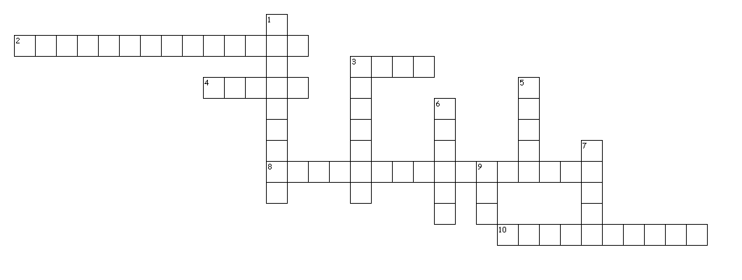

Across
2. person no longer a member of the Church
3. visible head of the Church
4. members of the Church who do not belong to the clerical or to the religious state
8. life of the Church (11,5)
10. soul of the Church (4,6)

Down
1. the day the Church began its work
3. assist the bishops in care of souls
5. Christ made him ruler of the Church
6. The Head of the Mystical Body
7. founded the Church
9. sent Holy Spirit to dwell in the Church

Designed in Puzzlemaker from DiscoverySchool.com

Answers:

Across
2. person no longer a member of the Church (excommunicated)
3. visible head of the Church (Pope)
4. members of the Church who do not belong to the clerical or to the religious state (laity)
8. life of the Church (sanctifying grace)
10. soul of the Church (Holy Spirit)

Down
1. the day the Church began its work (Pentecost)
3. assist the bishops in care of souls (priests)
5. Christ made him ruler of the Church (Peter)
6. The Head of the Mystical Body (Christ)
7. founded the Church (Jesus)
9. sent Holy Spirit to dwell in the Church (God)

